CWWS Fund – Capital Improvement Projects
Project Name:  Smith’s Fork Force Main | Department:  Public Works - Utilities
Type of Project:  Capacity | Contact:  Chuck Soules
Total Project Cost:
$600,000

Description:
Replacement of the existing 4 “ force main from Smith Fork Campground to Fourth Street and Spelman Dr.
Justification and Future Operating Costs:
The City completed the new lift station at Smith Fork Campground and found that the force main is partially plugged.
This project will also increase the pipe size to a 6’ force main for additional development.
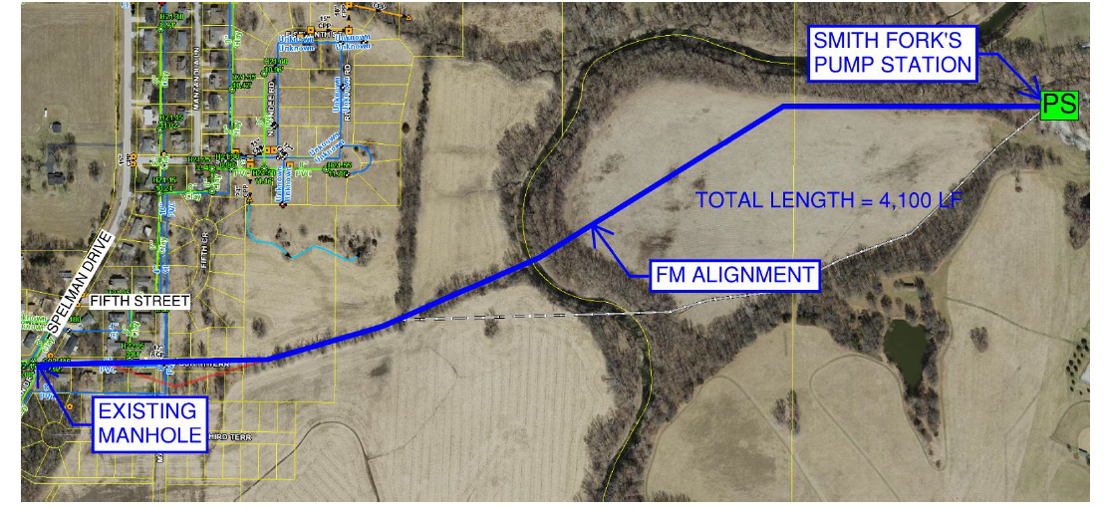

Planned Expenditures
 | FY2026 | Total
Construction | $600,000 | $600,000
Total | $600,000 | $600,000

Funding Sources
 | FY2026 | Total
CWWS Fund | $600,000 | $600,000
Total | $600,000 | $600,000

